Reading # 10

Concurrent Conflicts of Interest
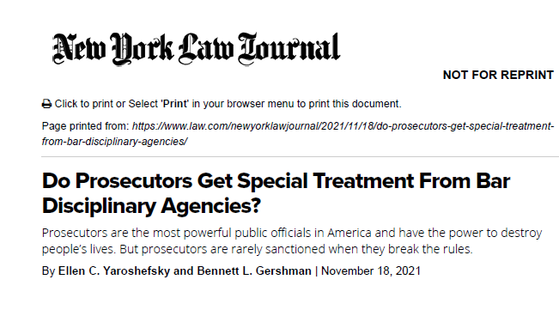
Conflicts of interest:

General rules:
• “Can’t go against your own client”
• “Can’t switch sides”
(go against a former client in substantially related matter)

[go against =
“directly adverse” … repr’n “materially limited”
..or take “materially adverse” position (successive)]
Adverse Consequences of conflicts:
• discipline
• damages liability for malpractice
• sanctions under Rule 11 or similar provisions
• delay of the client’s cause
• disqualification
• forfeiture of fees

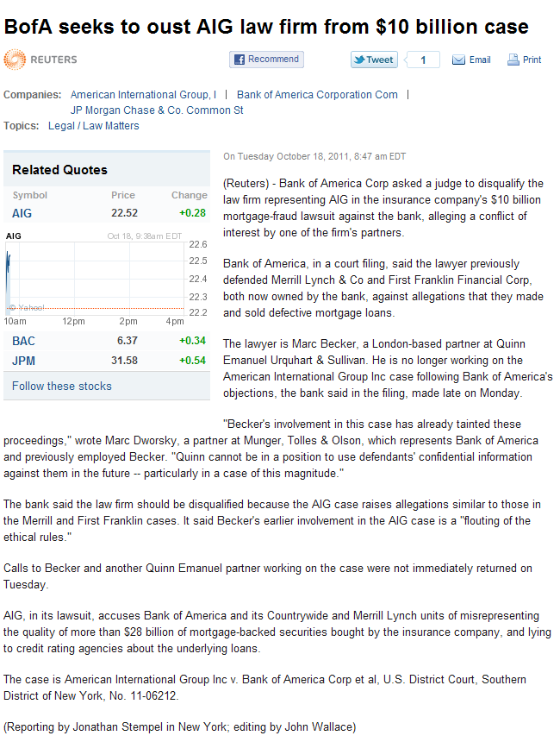

Concurrent conflicts (MR 1.7):

General rule:
• “Can’t go against your own client” →
• repr’n of one = “directly adverse” to another C
• significant risk repr’n will be “materially limited”

Exception:
• “informed consent, confirmed in writing”
Plus:
• L “reas believes” can give competent+diligent repr’n
• not prohibited by law
• doesn’t involve opposing claim in same litigation
or another proceeding

Miscellaneous “conflicts” (MR 1.8):
• business transactions with clients
• business interests “adverse” to client
• using client information to client’s disadvantage
• soliciting gifts from clients (esp. wills)*
• literary or media rights*
• no financial assistance to client*
• no accepting fees from other than clients
• no “aggregate settlements”
• no agmts prospectively limiting malpractice liability
• no proprietary interests in client’s lawsuit*
• no sex with clients*

Imputed conflicts—“can’t go against your partner’s client”

Business transactions with clients (MR 1.8(a)
(business transactions and interests adverse to client)
• terms: “fair, reasonable”; fully disclosed in writing
• C advised in writing of to seek advice
of independent counsel has reasonable oppy to do it
• C gives informed consent, in signed writing

Matter of Neville
• not limited to where L represents C in the deal→
• rule grounded in fiduciary duty (continues)
• Cs don’t turn confidence off and on
• Cs entitled to full disclosure in all dealings w/ atty

• Not enough for L to tell C “I don’t repr you in this”)
• C still might not recognize he’s “in a situation where
he must protect himself”

So..
• What’s a lawyer required to say for ‘full disclosure’?
• fully explain divergence of interest btwn L and C
• explain need to seek independent legal advice
• detailed expln of risks & disadvantages of deal to C

In short, to avoid discipline, even if C is not a “client,”
L must give C essentially everything that he’d get for C
if C were the “client” of L in the transaction
Gellman v. Hilal
ETHICS

When are personal relationships with opposing counsel conflicts? New ABA ethics opinion weighs in
BY DAVID L. HUDSON JR.
OCTOBER 7, 2020, 10:08 AM CDT
Lawyers’ personal relationships with opposing counsels may create a conflict under the ABA Model Rules of Professional Conduct, according to a new ethics opinion from the ABA’s Standing Committee on Ethics and Professional Responsibility.
Model Rule 1.7(a)(2) prohibits lawyers from representing a client if there is a significant risk that the lawyer’s representation will be materially limited by a personal interest of the lawyer.
Comment 11 to Model Rule 1.7 specifically identifies such a personal interest as when a lawyer is “closely related by blood or marriage” to opposing counsels. In such a case, the attorneys cannot handle the client’s case unless each client has given informed consent confirmed in writing.
Formal Opinion 494, released Wednesday, explains that other personal relationships—aside from marriage—can create a conflict for lawyers. The opinion analyzes three categories of relationships:
1. Intimate relationships
2. Friendships
3. Acquaintances
An ABA press release on the opinion is here.
Lawyers in intimate relationships with other opposing counsels or lawyers who are close friends with opposing counsels must disclose such relationships to their clients and often must obtain the informed consent of clients confirmed in writing, or they cannot represent the client, according to the opinion.

Intimate relationships
The opinion notes that “changing living patterns” suggest that more people may be living in the same household with “arrangements that do not correspond to traditional categories.”
“Lawyers who cohabit in an intimate relationship should be treated similarly to married couples for conflicts purposes,” according to the opinion. This includes those who are married, engaged to be married, or in “exclusive intimate relationships.” In these instances, lawyers must disclose the relationship to their respective clients and may not represent the clients unless each has given informed consent confirmed in writing.

Friendships
As for friendships, the opinion says those “may be the most difficult category to navigate.” Close friendships with opposing counsels should be disclosed to clients, according to the opinion. These include friendships in which the lawyers exchange gifts at holidays, spend time routinely at each other’s home, or vacation together with their families.
However, opposing counsels who were once law school classmates or who once practiced together but don’t see each other regularly ordinarily do not have to obtain clients’ informed consent and may not have to even disclose the relationship to clients.
“In sum, opposing lawyers who are friends are not for that reason alone prohibited from representing adverse clients,” according to the opinion. “The analysis turns on the closeness of the friendship.”

Acquaintances
The third category discussed are acquaintances. The opinion describes such relationships as those in which individuals see each other at gatherings, such as a professional organization or a church, but don’t feel “a close personal bond.”
“Lawyers who are acquaintances of opposing counsel need not disclose the relationship to clients, although the lawyer may choose to do so,” according to the opinion.
The opinion concludes by explaining that lawyers should examine the nature of the relationship to see whether it is one close enough to require disclosure and client consent, ending with a practice tip: “Disclosure may even be advisable to maintain good client relations.”

Simpson v. James

Elements to recover in malpractice:

• A duty to plaintiff (atty-client Rship)
• A breach of the duty
• Breach proximately caused P’s injury
• Amount of damages

Attorney-client relationship?

Enough to support jury verdict, namely:
• firm had repr’d Ps before the sale
• firm continued to repr them
in tax and estate matters after the sale
• James advised P she was getting a “good deal”

but .. “never gave any advice”
never charged for time”

Held: Evidence of negligence was enough for jury

Things that could have been done:
• put lien on the corp assets (as well as the stock)
• make sellers beneficiaries of insurance policies
• disclose buyer’s desperate financial condition
• pursue the insurance proceeds for seller
Malpractice—Basic Elements
• attorney-client relationship
• negligence or breach of contract
• a proximately caused loss to client
• but-for causation (“case within the case”)

Who is a Client?
When “circumstances” make it reasonably
foreseeable that the advice will be relied on
(that a “reasonable person” would rely on the advice)

Negligence: Ordinary care and diligence that a
reasonably prudent attorney would exercise
• research (?!)
• legal opinions & interpretations

Relevance of legal ethics rules
• Majority:
• rules = evidence of standard of care
• Minority:
• violation of the rules = negligence per se
• violation → rebuttable presumption of negligence
• the rules are totally inadmissible
Breach of Fiduciary Duties:
• no professional negligence is required
• no injury to client’s case is required (fee forfeiture)

Duty of Care → ordinary classic “malpractice”
Duty of Loyalty → breach of fiduciary duty

Ways a lawyer might breach fiduciary duty to client:
• Conflict of interest
• Capturing or diverting a business opportunity
• Using confidential client information (C’s disadv/L’s adv)
• Subverting agent of client to work agn client’s interests
• Taking any other unfair advantage of client (Tante
v. Herring).

. Fee Forfeiture and Disgorgement
• some courts: forfeit all
. • some courts: forfeit only fees accruing after the breach occurred
• some courts: amt depends on “facts and circumstances of the case”
Successive conflicts (MR 1.9):
General rule:
• “Can’t switch sides” (can’t go against former client) →
• in same or substantially related matter
• new C’s interests = materially adverse to former C’s

Exception:
• former C gives informed consent, confirmed in writing

Lawyer “switches sides” by switching firms:
Just as
• you can’t go against your own former client:
• in same or substantially related matter
• new C’s interests = materially adverse to former C’s

So also, if you move to a new law firm, you:
• you can’t represent any client against
a client of your former firm:
• in same or substantially related matter
• new C’s interests = materially adverse to former C’s
• if you acquired conf’l info material to the matter

And also:
• your whole new firm is disqualified..
..can’t represent a client against a client
that your old firm had while you were there:
• in same or substantially related matter
• if you shared confidences in prior firm
• if you share confidences in new firm (irrebuttable?)

Ergo, the “analysis” (as per Cromley):
• same or substantially related matter?
• shared confidences in prior firm? [rebuttable yes]
• shared confidences in new firm? [(ir)rebuttable yes)]

Therefore, if migrating L has confidential info re case:
• most would disqualify new firm from taking other side
• Cromley allowed new firm to “screen” new L

“Screening”
• instructions to other attys re L’s recusal
• ban on information exchange
• prohibited access to files & information on case
• locked case files w/ keys to a limited few
• secret codes on computers
• prohibition on sharing of fees from the litigation
⇒ employed as soon as ‘disqualifying event occurs’

“Other factors”:
• size of firm
• likelihood of contact btwn “tainted” & litigating attys
• firm’s reputation for honesty and integrity
⇒ DistCt must “find as a fact” that the “safeguards
did shield effectively”

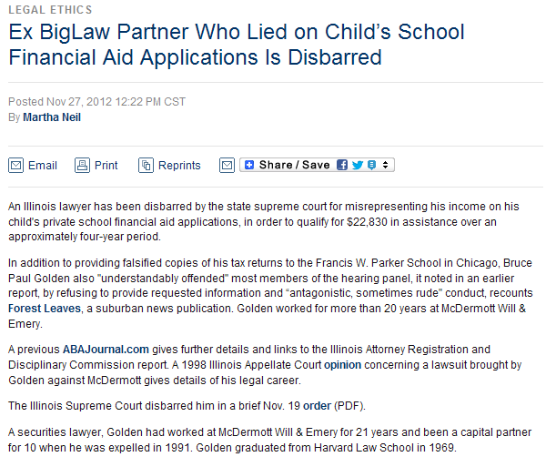

http://www.abajournal.com/news/article/ex_biglaw_partner_who_lied_on_childs_school_financial_aid_applications/?utm_source=maestro&utm_medium=email&utm_campaign=weekly_email
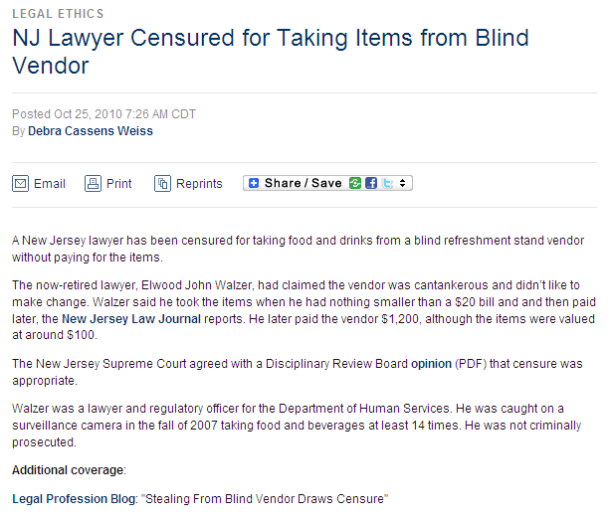

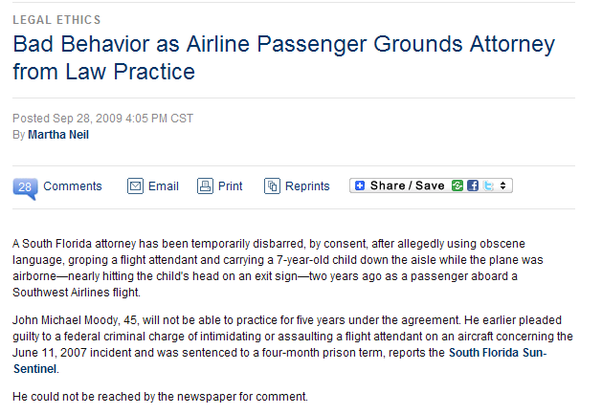
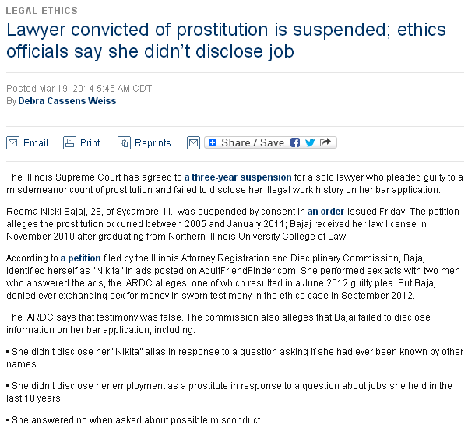



http://www.abajournal.com/news/article/lawyer_convicted_of_prostitution_is_suspended_ethics_officials_say_didnt/?utm_source=maestro&utm_medium=email&utm_campaign=weekly_email

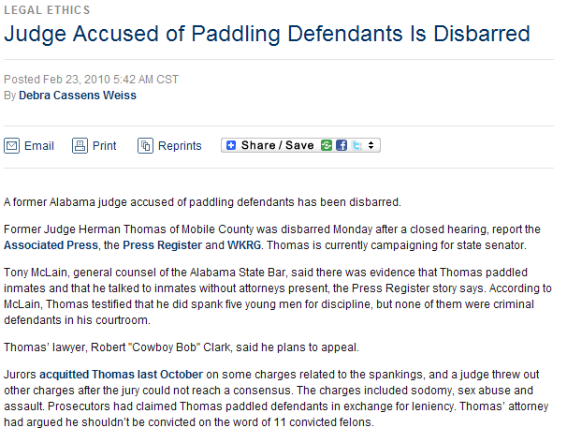
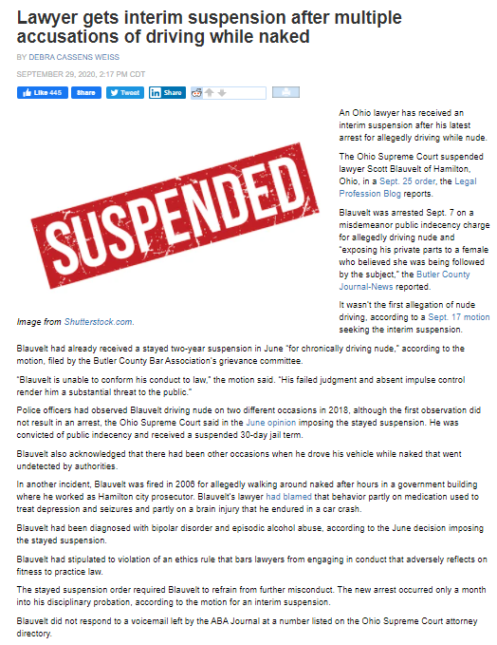

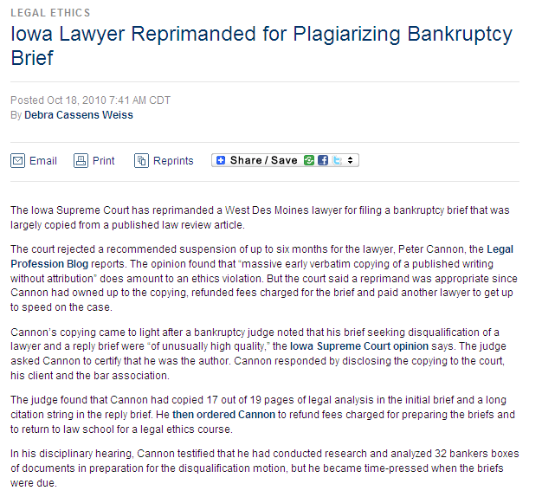
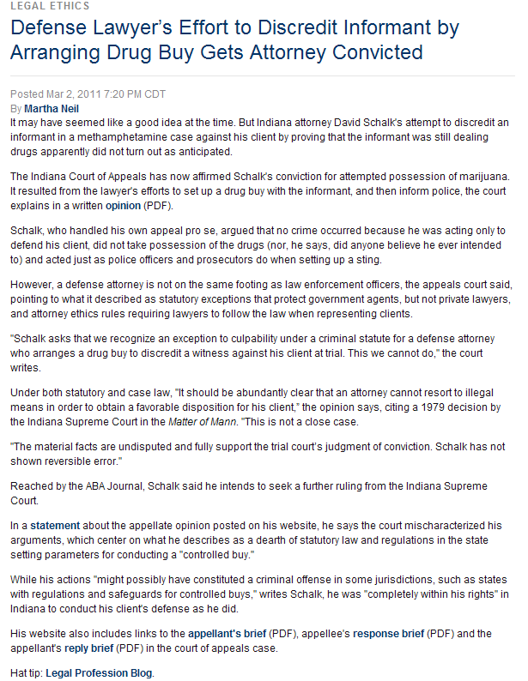

http://www.abajournal.com/weekly/article/defense_lawyers_effort_to_discredit_informant_by_arranging_drug_buy_gets_at?utm_source=maestro&utm_medium=email&utm_campaign=weekly_email

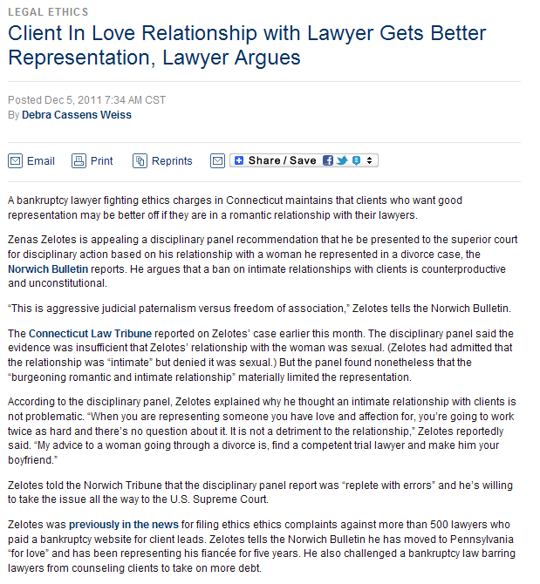

http://www.abajournal.com/news/article/lawyer_argues_clients_who_have_relationships_their_lawyers_get_better_repre/?utm_source=maestro&utm_medium=email&utm_campaign=weekly_email

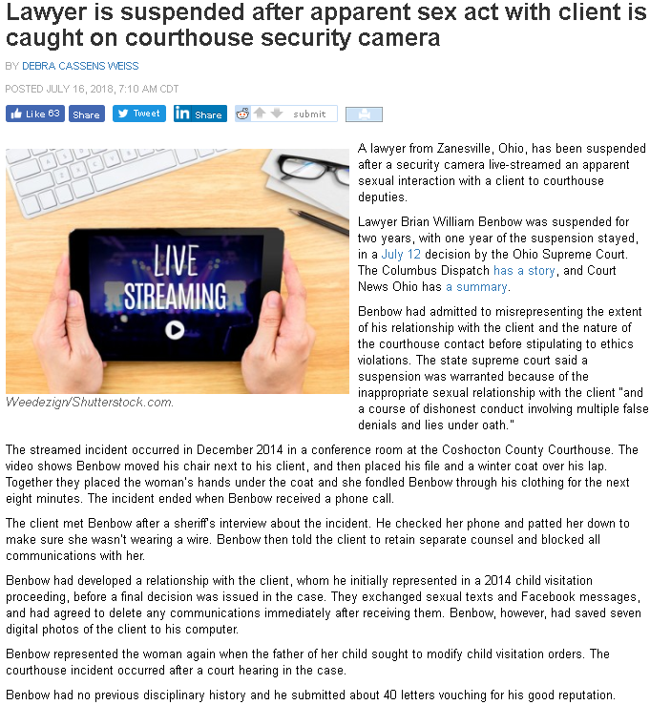

http://www.abajournal.com/news/article/lawyer_is_suspended_after_apparent_sex_act_with_client_is_caught_on_courtho/?utm_source=maestro&utm_medium=email&utm_campaign=weekly_email
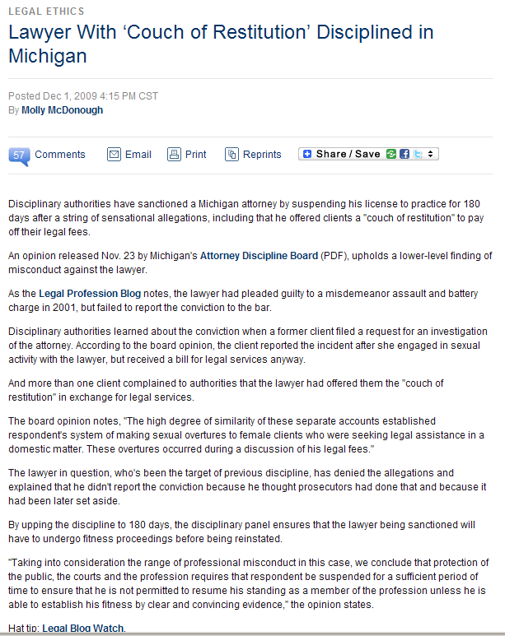
Malpractice—Basic Elements
• attorney-client relationship
• negligence or breach of contract
• a proximately caused loss to client
• but-for causation (“case within the case”)

Who is a Client?
When “circumstances” make it reasonably
foreseeable that the advice will be relied on
(that a “reasonable person” would rely on the advice)

Negligence: Ordinary care and diligence that a
reasonably prudent attorney would exercise
• research (?!)
• legal opinions & interpretations

Relevance of legal ethics rules
• Majority:
• rules = evidence of standard of care
• Minority:
• violation of the rules = negligence per se
• violation → rebuttable presumption of negligence
• the rules are totally inadmissible
Breach of Fiduciary Duties:
• no professional negligence is required
• no injury to client’s case is required (fee forfeiture)

Duty of Care → ordinary classic “malpractice”
Duty of Loyalty → breach of fiduciary duty

Ways a lawyer might breach fiduciary duty to client:
• Conflict of interest
• Capturing or diverting a business opportunity
• Using confidential client information (C’s disadv/L’s adv)
• Subverting agent of client to work agn client’s interests
• Taking any other unfair advantage of client (Tante
v. Herring).

. Fee Forfeiture and Disgorgement
• some courts: forfeit all
. • some courts: forfeit only fees accruing after the breach occurred
• some courts: amt depends on “facts and circumstances of the case”

