Recall:

Estates classified according to

Potential Duration

The FREEHOLD estates:
• Fee simple absolute
• Fee simple determinable
• Fee simple on condition subsequent
• Fee simple on executory limitation
• Fee Tail
• Life Estate

The Non-FREEHOLD estates:
• Term of Years
• Periodic Tenancies
• Tenancy at Will
The non-freehold estates

• Term of Years -- "on or before a definite date"

• Periodic Tenancies -- from month to month, etc.

• Tenancy at Will -- until party ceases to will, dies

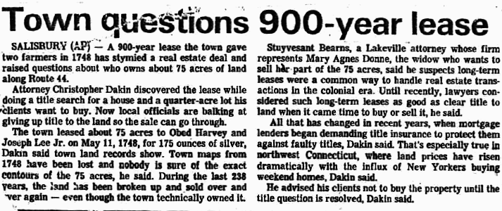

Term of Years:
• created by a "demise"
(cf. “devise,” “surrender,” “release”)

landlord "demises" possession to tenant w/ def date,
creating a term [of years] and a reversion
• landlord = reversioner
• tenant = termor

A leasehold estate is a "chattel real"

Statute of Frauds (1677):
"no interest in real property can be created or
transferred w/o a writing
signed by the creator or transferor"

Exception: Short-term leases
(in NY, leases for one year or less)
Periodic tenancies:
• year to year
• month to month
• week to week
• other?

Created by:
• express agreement
• implication (e.g., upon a VOID lease (S/F))

Key features:
• one long continuous tenancy (not discrete terms)
• required notice to terminate: one term
• may be terminated only as of end of a period

Suppose a tenancy from month to month,
beginning last November 15th

Earliest possible termination?
•January 15?
•January 31?
•February 15?

Notice to terminate a Term of Years?
• Tenant at sufferance
• trespasser
• hold for new term
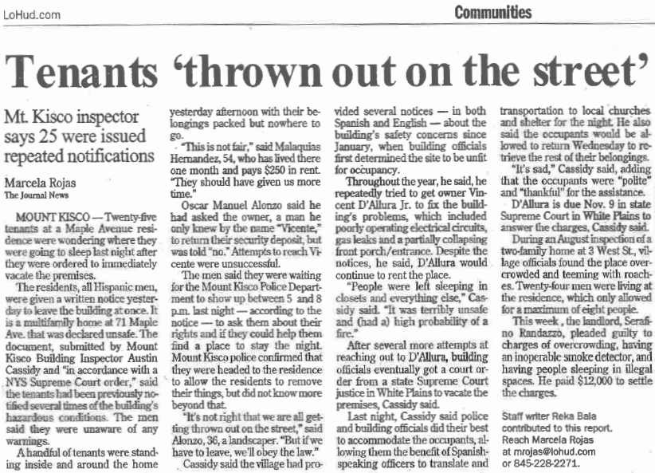

Leases

• Contract?

-or-

• Conveyance?

Dual Relationship:

• Privity of Contract
(based on promises)

• Privity of Estate
(based on ownerships)

Dual Relationship:

• Privity of Contract
(based on promises)
• L's promise to allow possession
• T's promise to pay rent

• Privity of Estate
(based on ownerships)
• L conveys possession to T, for whole term
• Rent is reserved by L, captured by T for L
(like selling the cow but reserving the milk)

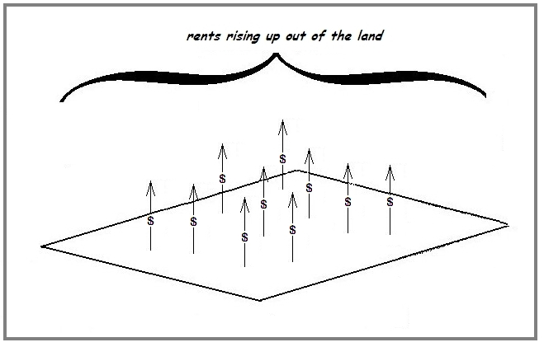

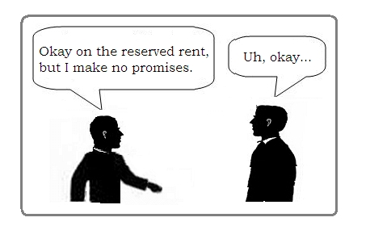

Principal overlap of privities of contract & estate =
rights and duties in basic rent-possession exchange

"Strange" results:
• non-pmt of rent → no common-law forfeiture

• eviction does extinguish rent obligation
..but “eviction” requires ouster by:
•landlord
•paramount title

• deterioration, actions of 3rd parties, accidents →
no effect on rents
(T, as "owner," bears risks of O-ship)

• "Independence of Covenants"
• constructive eviction ("untenantable")
• breach of duty by landlord
• tenant abandons possession
• rent obligation ceases

Assignment vs. Subletting

Assignment = “transfer” of an existing leasehold

Subletting = creation of a new landlord/tenant R-ship

Subletting:

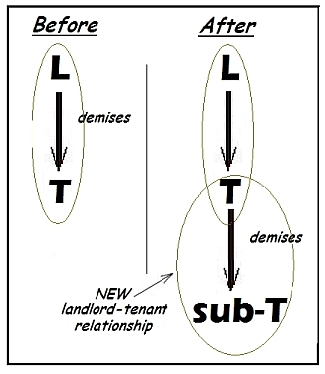

• New landlord-tenant relationship
• Subtenant becomes tenant of tenant
• Prime tenant remains in privity of estate

Assignment:

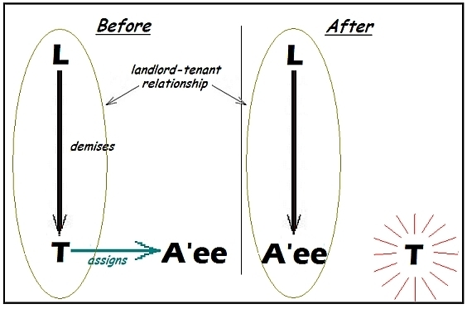

• Same landlord-tenant relationship
• Assignee takes place of assignor
• Assignor ceases to be in privity of estate

Basic Effect of Assignment

• Assignee is liable in estate

• Assignee is liable in contract? (assumption?)

• Assignee is liable on covenants that run w/ land
◦ intent to run with land
◦ “touch & concern” the land
◦ privity of estate

• Assignor remains liable in contract (“surety”)

• Assignee is liable to assignor (“subrogation”)

• Novation?

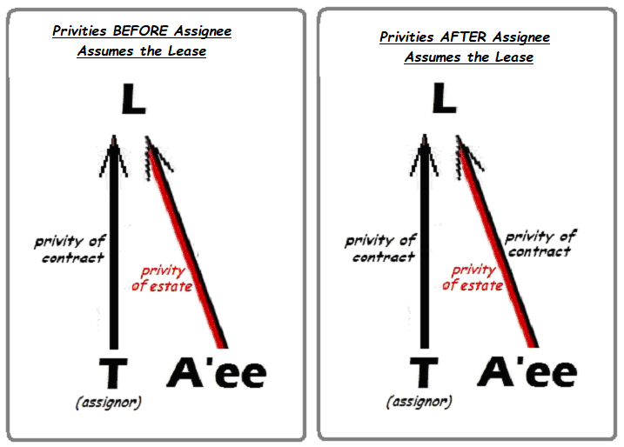

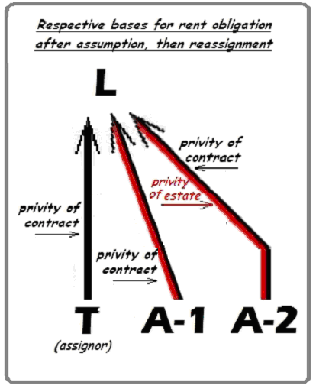
Vallely Investments v. Bancamerica

Vallely (plaintiff)
↓ leased 1978
Developer
↓ ass’d
unnamed assignees
↓ ass’d
Balboa
↓ ass’d 1989
BACC
↓ Foreclosure sale 1989
BA Mortgage
↓ ass’d 1994
Edgewater

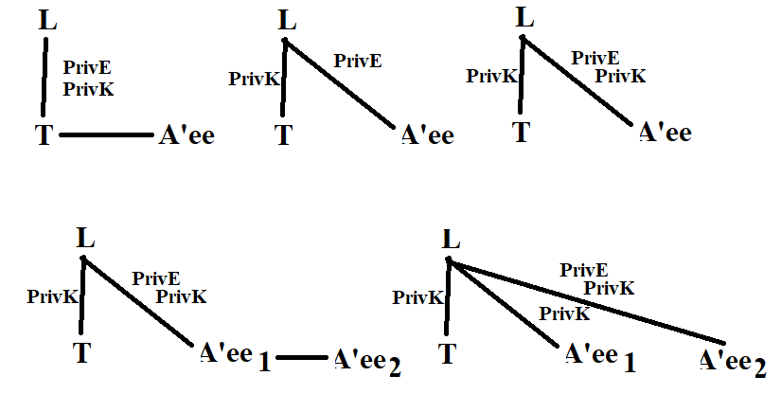

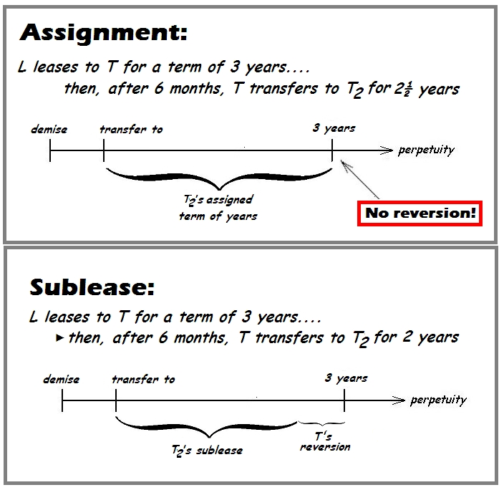

Dual Relationship:

• Privity of Contract
(based on promises)

• Privity of Estate
(based on ownerships)

"Strange" results of overlap of privities
in basic rent-possession exchange:

• non-pmt of rent → no common-law forfeiture

• eviction does extinguish rent obligation
..but “eviction” requires ouster by:
•landlord
•paramount title

• actions of 3rd parties, accidents →
no effect on rents
(T, as "owner," bears risks of O-ship)

• "Independence of Covenants"
• constructive eviction
• breach of duty by landlord
• "untenantable"
• tenant abandons possession

• rent obligation ceases

"Strange" results of overlap of privities
in basic rent-possession exchange:

• …
• …
• …
• "Independence of Covenants"
• constructive eviction ("untenantable")
• breach of duty by landlord
• tenant abandons possession
• rent obligation ceases

Implied Warranty of Habitability (Javins; Park West):

Main Exchange (traditional):

RENT ↔ POSSESSION

Main Exchange (modern):

RENT ↔ POSSESSION + SERVICES

• Reasons for implied warranty of habitability:
• custom, usual practice, practical necessity →
centralized repair and service responsibility
• Residential T must rely on L for upkeep
• Legal theories:
• req'ts of law are implied into lease
• intention of parties: "livable"

• Standards of habitability:
• housing codes (substl violation = p/f evidence)
• suitable for purpose for which leased (residence)
• threats to tenant health & safety
• more than de minimis
• more than merely not “perfect” or non-aesthetic
Implied Warranty of Habitability (cont'd):

• Remaining problem: "independence of covenants"

• Javins/Park West solution:
"treat leases like ordinary contracts"

“Ordinary Contract Law”
"material breach by one party excuses the other"

But...
"acceptance . . . of a defective performance,
eliminates the excuse"

That is: You can't have it both ways
(take the defective performance and not pay for it)

• Better solution: Conveyance theory

• "courts abhor forfeiture"
• relieve against it if money is offered as cure
Restatement (Second) of Contracts §237 and §246

§237. Effect on other party's duties of a failure to render performance
[I]t is a condition of each party's remaining duties to render performances to be exchanged under an exchange of promises that there be no uncured material failure by the other party to render any such performance due at an earlier time.

§246. Effect of acceptance as excusing the non-occurrence of a condition
(1) Except as stated in Subsection (2), an obligor's acceptance or his retention for an unreasonable time of the obligee's performance, with knowledge of or reason to know of the non-occurrence of a condition of the obligor's duty, operates as a promise to perform in spite of that non-occurrence, * * *

(2) If at the time of its acceptance or retention the obligee's performance involves such attachment to the obligor's property that removal would cause material loss, the obligor's acceptance or retention of that performance operates as a promise to perform in spite of the non-occurrence of the condition, * * *, only if the obligor with knowledge of or reason to know of the defects manifests assent to the performance.

Restatement (Second) of Contracts §237 and §246
[simplified]

§237. Effect on other party's duties of a failure to render performance
It is a condition of each party's remaining duties that there be no uncured material failure by the other party to render any performance due at an earlier time.

§246. Effect of acceptance as excusing the non-occurrence of a condition
An obligor's acceptance of the obligee's performance, with knowledge of the non-occurrence of a condition of the obligor's duty operates as a promise to perform in spite of that non-occurrence, * * *

(2) If at the time of its acceptance the obligee's performance involves such attachment to the obligor's property that removal would cause material loss, the obligor's acceptance of that performance operates as a promise to perform in spite of the non-occurrence of the condition, * * *, only if the obligor with knowledge of the defects manifests assent to the performance.

Tenant Breaches (Rule of Mitigation):

If T wants to terminate early →
• surrender
• abandons (wrongful)

If T wrongfully abandons, L may:
• do nothing & hold tenant for full rent
• accept “proffered surrender"; relet for own acct
• notify T: entering & reletting on T’s acct

What about a plain attempt to relet (w/o notification):
• = “acceptance of proffered surrender"
• exception: "survival clause"

Note difference:
• L sues for rent as it accrues (estate; no mitigation)
• L sues for damages, for anticipatory breach
(mitigation “required”)

